MADHAV INSTITUTE OF TECHNOLOGY AND SCIENCE, GWALIOR

SUBMITTED BY-

ASMITA JAIN

0901EO201017

SUBMITTED TO-

PROF. APRAJITA KUMARI

**SENSOR TECHNOLOGY LAB 220202**

**EXPERIMENT - 10**

**AIM:**

TO DRAW THE CHARACTERISTICS OF PHOTOTRANSISTOR

**APPARATUS REQUIRED:**

* DIGIAC 1750 Transducer and Instrumentation Trainer.
* 4mm Connecting Leads.
* 2 x Digital Multimeters.
* Opaque box to cover the clear plastic enclosure.

**THEORY:**

A Phototransistor is a device that has the ability to detect the level of the incident radiation and accordingly change the flow of electric current between emitter and collector terminal.

*WORKING PRINCIPLE*:

It operates on the principle of Photoelectric effect. As it changes light signal incident on its surface into its electrical equivalent form.

*ABOUT PHOTOTRANSISTOR:*

• It is a 3-layer semiconductor device that consists of a light sensitive base region. It is basically a transistor whose action depends on the application of light. Hence named phototransistor.

• The phototransistor is basically an enhancement of Photodiode.

• Both photodiode and phototransistor are light sensing device but the sensitivity of phototransistor is somewhat more as compared to the photodiode.

• As phototransistor has the ability to give larger gain than that of the photodiode.

**CIRCUIT DIAGRAM:**

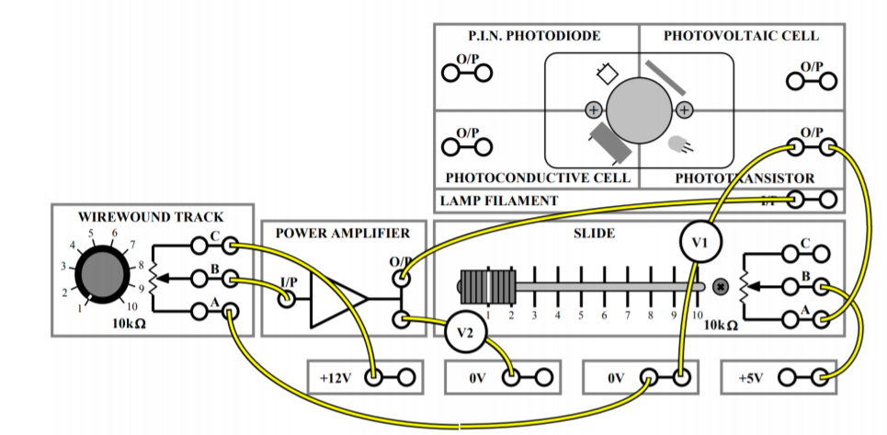

**OBERSERVATION TABLE:**

|  |  |  |  |  |  |  |  |  |  |  |
| --- | --- | --- | --- | --- | --- | --- | --- | --- | --- | --- |
| Lamp filament  Voltage(V) | 1V | 2V | 3V | 4V | 5V | 6V | 7V | 8V | 9V | 10V |
| Photo  Transistor  Voltage(V) | 5 | 5 | 4.92 | 4.30 | 2.73 | 0.82 | 0.77 | 0.75 | 0.74 | 0.73 |

**GRAPH:**

**LAMP FILAMENT VOLTAGE(V)**

**PHOTO TRANSISTOR OUTPUT VOLTAGE(V)**

**APPLICATION:**

*SLOTTED OPTO TRANSDUCER:*

The **slotted optical switch**, sometimes known as **opto switch** or **optical switch**, is a device comprising a photoemitter and a photodetector mounted in a single package so that the photoemitter normally illuminates the photodetector, but an opaque object can be inserted in a slot between them so as to break the beam.

**RESULT:**

Hence, we have studied about the principle and application of phototransistor and verified the characteristics of phototransistor.